*Pollution, 6(1): 149-157, Winter 2020*

DOI: 10.22059/poll.2019.288505.676

Print ISSN: 2383-451X Online ISSN: 2383-4501

Web Page: https://jpoll.ut.ac.ir, Email: [jpoll@ut.ac.ir](mailto:jpoll@ut.ac.ir)

**Nitrate Bioremoval by Phytotechnology using *Utricularia aurea* Collected from Eutrophic Lake of Theerthamkara, Kerala, India**

**Usharani, K.1&2* and Keerthi, K.V.2**

* 1. Department of Environmental Science, Division of Environmental Microbiology, PSG College of Arts and Science, TN-641014, India

1. Department of Environmental Science, Central University of Kerala, KL-671320, India

Received: 05.08.2019 Accepted: 23.11.2019



**ABSTRACT:** The aim of this study was to compare the selected aquatic plants ability toremove nitrate from wastewater. Excess of these nutrients in water can directly affect human health (methemoglobinaemia) or indirectly through the products of secondary pollution include eutrophication. Negative impact of nutrients excess in surface water often causes the destruction of water ecosystems, and therefore, common substances of these elements must be monitored and managed. Spectrophotometric technique was commonly used for quick and simple analyses of nutrients in waste water. There are calibration curves for each nutrient and for the determination of their concentration. Phytotechnology is one of the biological wastewater treatment methods or processes to eliminate nitrate contaminant from aquatic system. So as to avoid the eutrophic formation of fresh water and to determine the efficiency of nitrate utilization by specific aquatic plants which include *Utricularia aurea* and *Salvinia molesta* were collected from a eutrophic lake at Theerthamkara, Kerala. The samples were allowed to grow in nitrate solution for about one month at different concentrations. The optical density (OD) of nitrate solution at 410 nm was measured on alternative days of the experiment by using UV spectrophotometer. After 33 days of treatment periods, the maximum amount of nitrate removed in terms of percentage was found to be 95% by *Utricularia aurea* and 92% by *Salvinia* molesta at 100 ppm nitrate concentration. The results revealed that the aquatic plant (carnivorous) based system of phytotechnology was productively removed the nitrate load from the synthetic wastewater containing nitrate.

**Keywords:** Aqueous Nitrate; Phytoremediation*;*Aquatic free floating plants.



**INTRODUCTION **

Pollution of water resources by excessive presence of nitrogen compounds such as nitrate, nitrite and ammonium, is a real health and environmental problem. Nitrate excess in drinking water may cause blue disease in babies called methemoglobinemia in new born infants as well as other illnesses (Ozturk and Bektas, 2004). The most important

* Corresponding Author, Email: [usharaniks2003@yahoo.com;](mailto:usharaniks2003@yahoo.com) usharanik05@yahoo.com

environmental problems caused by nitrogen

and phosphorus compounds are eutrophication of water supplies and infectious disease (Barber and Stuckey, 2000). These components which are involved in the eutrophication of surface waters and the presence of high levels of nitrate and nitrite ions in drinking water has an adverse risk to human health (Jorgensen, 2001; Viessman et al., 2005; Chiban et al., 2012; World Health Organization, 1984). In

149

*Usharani, K. and Keerthi, K.V.*

addition, excessive levels of nitrate ions in drinking water may cause health problems, especially for infants under six months of age and pregnant women (Seidel et al., 2011). The Maximum Acceptable Concentration (MAC) for nitrate-nitrogen in Canadian drinking water has been established as 10 mg N-NO3-/L (Health Canada, 2003 and WHO, 2007). Moreover, in 1990, environmental protection agency (EPA) indicated that 250,000 water supply sources had maximum contaminant levels (MCL) for nitrate. In the body system, when nitrate is converted to nitrite, it reduces the oxygen-carrying capacity of the blood, resulting in a condition called "methaemoglobinaemia", also known as "blue baby syndrome"(World Health Organization, 1984). Nitrite has been shown to cause methaemoglobinaemia in animals. Anyway, nitrite when present at high concentration in blood can react with Fe (II)

of the haemoglobin, forming methaemoglobin [NO2- + oxyHb (Fe2+) → metHb (Fe3+) + NO3-] which has no oxygen-carrying ability. This condition is called methaemoglobinaemia (Dejam et al., 2005, Rawat et al., 2012). Moreover, the reaction between nitrite and secondary or tertiary amine in acidic media such as in the human stomach could result in the formation of Nitroso compounds (NOC), which are known to be carcinogenic, teratogenic, and mutagenic (Mikuska et al., 2003).

Nitrate pollutant leads to increase in the growth of algal bloom those results in eutrophication of fresh water. It has become the most serious environmental problem in our area since it causes algae blooms. Growth of algae decreases the dissolved oxygen concentration of water that final result is the death of fish and other aquatic organisms. The major source of nitrogen pollution are the nitrate (NO3-) that mainly originated from the emission of industrial wastewater and the use of excess fertilizers in agricultural fields. Nitrate removal and emission of N2O in wetlands can vary spatially, depending on factors

such as vegetation, hydrology and soil structure (Mwagona et al., 2019).

Phytotechnology involves growing plants in a contaminated matrix, for a required growth period, to remove contaminants from the matrix, or facilitate immobilization or degradation (detoxification) of the pollutant. Aquatic plant based bioremediation (Phytotechnology) is one of the biological wastewater treatment methods or processes to eliminate nitrate contaminant from aquatic system. So as to avoid the eutrophic formation of fresh water and to determine the efficiency of nitrate utilization by specific aquatic plants (*Utricularia auria*, *Salvinia* *molesta*) are used for the study and determineits efficiency to denitrify high nitrate load in wastewater. Bladderworts are usually found in wet soils in open areas, ponds and lakes, streams, and on rocks or tree trunks (Taylor, 1989). The *Utricularia* plant was screened of bioactive compounds for formulation of new drugs and the paper suggests that the conservation of such rare insectivorous plants was essential. *Utricularia reniformis* can be terrestrial, epiphytic or even lithophytic, and *Utricularia gibba*, which is commonlyaquatic and has also be found on emergent and submerged leaves of Salvinia, a common fern found in ponds, and thus can be considered as an epiphyte (Saura et al., 2018).

From the literature survey, so far no reports have been found or scientific papers published on nitrate removal efficiency from nitrate rich wastewater using aquatic free floating plant *Utricularia aurea*. The main purposes of using this system have focused on waste stabilization and nutrient removal. This study was aimed to examine the removal potential of nitrate by selective aquatic plants *Utricularia aurea* and *Salvinia* *molesta* isolated from eutrophic lake watersample according to the variance of residence times and concentrations of nitrate.

**MATERIAL AND METHODS**

The aquatic plants used for the nitrate removal study from nitrate containing

150

*Pollution, 6(1): 149-157, Winter 2020*

synthetic wastewater are *Utricularia auria* and *Salvinia molesta*. These aquatic plants were collected from a eutrophic lake from Theerthamkara. The plants were washed thoroughly with distilled water to remove the particles adhering to the plants, and transferred to a container (Fig.1 and Fig.2). The collected *Utricularia aurea* where washed and cut the tip portion up to 6 cm length (noted the nodes and internodes to determine the growth of the plant).

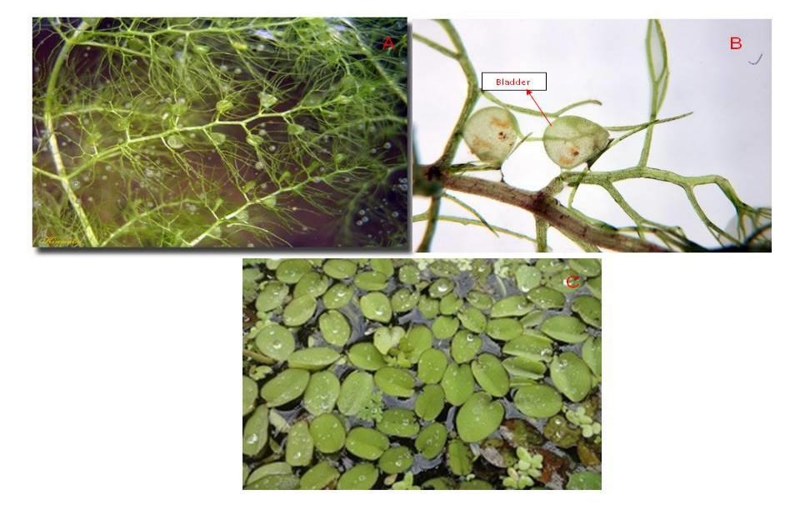

Inoculate the cut portion in to each conical flask containing different concentration of nitrate (from 100 to 1000 ppm) and allowed to grow for months (Fig.1 and Fig.2). The collected *Salvinia molesta* where washed and cut the plant in a way that each portion containing five leaves. Inoculated the cut portion in to the nitrate solution containing different concentration (from 100 to 1000 ppm) and allowed to grow for months (Fig.1 and Fig.2).

**Fig. 1. *Utricularia aurea* (a) with bladder, (b*)* enlarged bladder and (c) *Salvinia molesta***

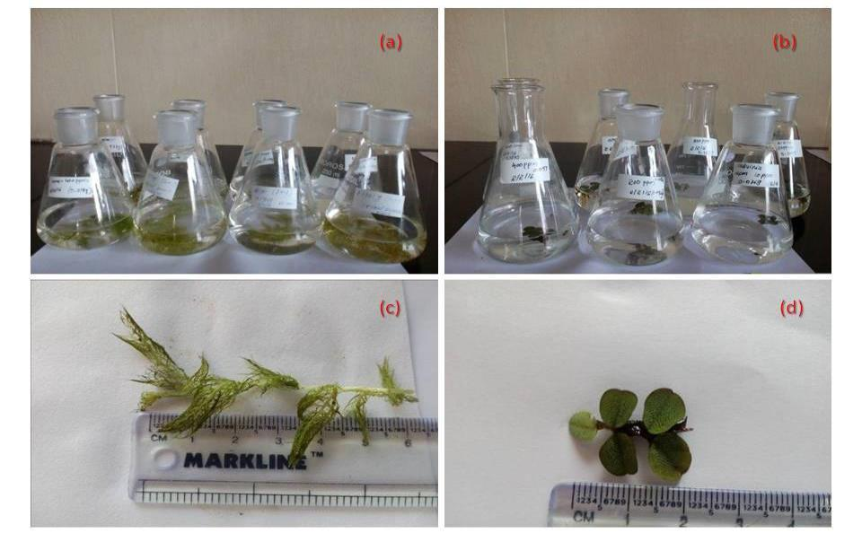

**Fig. 2. (a) *Utricularia aurea ,* (b) *Salvinia molesta* inoculated in different concentration of nitrate solution and (c) *Utricularia aurea* plant with 6cm length and (d) *Salvinia molesta* having 5 leaves**

151

*Usharani, K. and Keerthi, K.V.*

Stock solution was prepared using potassium nitrate; one gram of potassium nitrate was weighed and transferred in to a standard flask and make up the volume to 1000ml in a standard flask using deionised water. From that stock solution of nitrate solutions working solution were prepared with different concentrations (from 100 to 1000 ppm). Calibration Graphs consists of a plot of absorbance versus concentration for a series of standard solutions whose concentrations are accurately known.

Aquatic freefloating young plants, *Utricularia aurea* with an average length ofsix centimetres and *Salvinia molesta* with five leaves were selected and used for the nitrate removal experiments. The fresh weights of the plants were determined using a physical balance (gravimetric method), after removing water by blotting using filter paper. The total leaves, roots, nodes, side branches etc., of the plant were determined. The cleaned plants were introduced into each different concentration of nitrate solution in each different 250ml conical flask, with the roots submerged in the solutions and kept under sun light (Fig.2). The nitrate level in the synthetic solution was estimated at different time intervals by Salicylic acid method (APHA, 1998) using

spectrophotometer UV-2600 series SHIMADZU). Control experiments were also performed with the same nitrate solution concentrations, but without aquatic plant. All experiments were performed in triplicates.

For the analysis of nitrate solution, about 0.25 ml sample solution is pipette out into a 50 ml beaker. To that add 0.8 ml of 5% (w/v) salicylic acid in conc. H2SO4. After 20 minutes add 19 ml NaOH, this is to raise the pH above 12. Then the samples were allowed to cool and measured the absorbance in terms of optical density (OD) at 410nm using a UV-Visible spectrophotometer. The initial and residual concentration of nitrate in terms of optical density (OD) value was measured using

UV-Visible spectrophotometer (UV-2600 series SHIMADZU). From this value, the percentage nitrate reduction or removal was calculated. Nitrate uptake efficiency

1. was calculated using the formula, E = [(I-F)/I] × 100/ growth of plants (biomass). Where, I and F are the Initial and Final concentrations of nitrate respectively. Growth of the plant (biomass) was measured in terms of measuring the length (cm) and counting the number of leaves. An efficiency value of 100% was obtained when no nitrate appeared in the treated water sample (i.e., F = 0) (Usharani et al., 2011, 2017).

The pH change in treated wastewater at different concentrations with different time intervals by the free floating aquatic plants were estimated using digital pH meter (Scientific Tech, Advanced pH meter, mode ST -2002).

**RESULTS AND DISCUSSION**

The aquatic carnivorous plant Utricularia has one of the smallest known genomes among flowering plants, and therefore, it is an excellent model organism for physiological

and developmental studies (Joanna Augustynowicz et al., 2015). Collected plant samples of *Utricularia aurea* and *Salvinia molesta* are allowed to grow in nitrate solution for a month and used for our study. The capacity of the plant to remove nitrate at concentrations from 100 to1000 ppm were shown in the figure.3. Both the plants showed the nitrate removal property. In this study both aquatic plants showed similar activity that means they are similar in rate of nitrate removal. The maximum removal was observed after 33st day and the percentage nitrate removal and its growth in terms of optical density (OD) was given in figure 4. It showed that the maximum removal (95%) was occurred at 100ppm (Fig.4) and the minimum percentage removal (15%) was occurred at 1000ppm (Fig.3) by *Utricularia aurea.* In the case of *Salvinia molesta* maximum removal (95%) was

152

*Pollution, 6(1): 149-157, Winter 2020*

occurred at 100ppm (Fig.3) and the minimum percentage removal (14%) was occurred at 1000ppm (Fig.3) (Usharani and Keerthi, 2018). At higher nitrate concentrations, the plant (*Utricularia aurea)* was unable to remove nitrate due to the high concentration of nitrate affecting the uptake of nitrate in the root system due to the osmotic pressure. The growth of the plant and the removal efficiency are depending not only on the type of nutrients available but also on the interactions between environmental factors such as pH (Abdel-Raouf *et al*., 2012). During this study the pH value decreased from 7.35 to 6.52 in the presence of *Utricularia aurea* (Figure.5)*. Utricularia aurea* was a potentially aquatic plant tostabilize the pH, may reduce the chemical oxygen demand (COD) and also reduce the nitrate concentration. However, *Utricularia* *aurea* is insufficient in trapping moreparticles after several days (Nor Baizura Hamid *et al*, 2015)*.* In the case of *Salvinia* *molesta* pH reduces from 7.35 to 7.3 that theyshowed less variation in pH (Figure.5).

Figure 4A, showed the percentage nitrate removal by *Utricularia aurea* was calculated from its residual nitrate concentration present

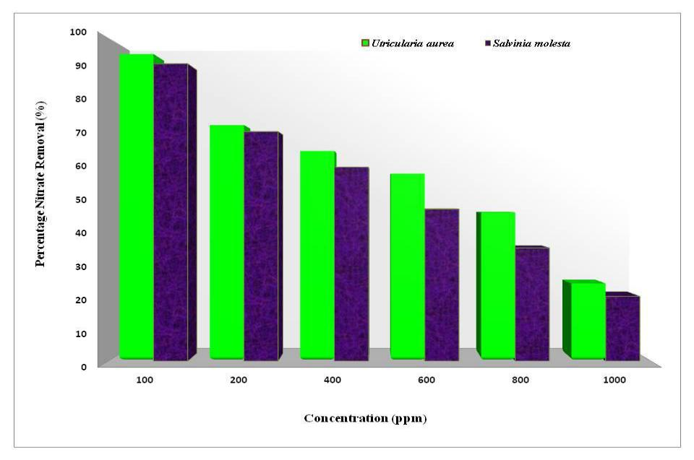

in 100 ppm of nitrate solution at different treatment time intervals. This showed the OD value of Nitrate solution decreases from the initial day to the final day. From the figure 4B, the *Salvinia molesta* with residual nitrate concentration at different treatment time was represented interms of OD value. From this figure 4A and 4B, the nitrate solution was found to be decreased its concentration from the initial day to the final day (after 33 days). In 100 ppm of nitrate wastewater, Utricularia *aurea* showed higher nitrate reduction after 33 day of treatment time then the *Salvinia molesta* treatment.

At the initial stage of treatment days

*Utricularia aurea* showed higherabsorbance of nitrate solution. From the initial stage of treatment onwards, the *Utricularia aurea* showed lesser residualconcentration of nitrate in terms of OD value than *Salvinia molesta* and it showed the higher efficiency of nitrate removal while comparing *Salvinia molesta*. In this data *Utricularia aurea* was found to be higher ability to remove nitrate from nitrate rich wastewater. *Salvinia molesta* showed less capability to remove nitrate when compared to *Utricularia aurea*.

**Fig. 3. UV spectral analysis of nitrate removal by *Utricularia* and *Salvinia* at different nitrate concentration (from 100 to 1000 ppm) after 33 days**

153

*Usharani, K. and Keerthi, K.V.*

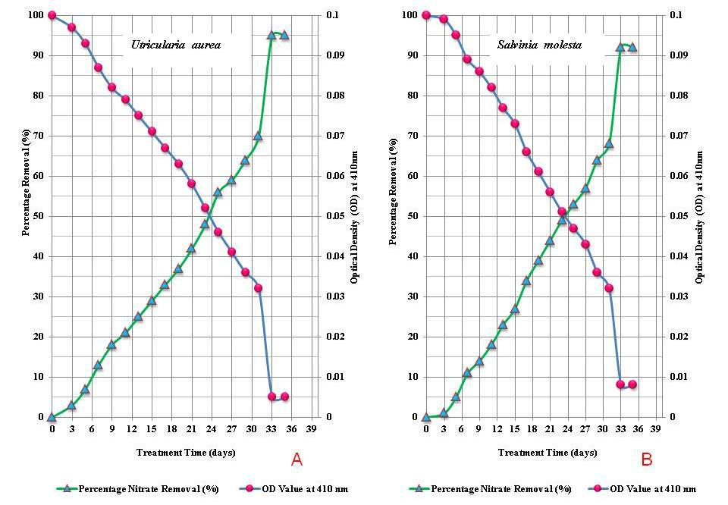

**Fig. 4. UV spectral analysis of nitrate removal in terms of optical density (OD410nm) and percentage removal (%) by (a) *Utricularia aurea* and (b) *Salvinia molesta* at 100 ppm nitrate concentration after 33 days**

Similar trends were observed in various treatments at different nitrate concentrations. From the initial days of treatment to final day after 33 days of treatment period, *Utricularia* *aurea* was observed to be higher uptake ofnitrate nutrient from the nitrate rich wastewater. Which indicate that the free floating aquating plant, *Utricularia aurea* treated wastewater contains the lesser residual nitrate concentration (OD value) after every treatment time than the *Salvinia* *molesta*, that showed *Utricularia aurea* removed more nitrate (95%) after 33days of

treatment period. Amount of nitrate removed maximum 95% at100ppm and minimum 24% at 1000ppm by *Utricularia* *aurea.* Contact time is one of the importantparameters for successful use of the biosorbents for practical application and rapid sorption is among desirable parameters (Amalina et al., 2016; Usharani and Keerthi, 2018).

Figure 5, showed the pH change at different treatment period in days. *Utricularia aurea* showed the reduction in

pH that the basic solution turned in to normal pH of water. *Utricularia aurea* has the potential to change pH to neutral. *Salvinia molesta* showed the pH change inslight but it remains as such and maintain a pH range between 7.35.to 7.3 (Usharani and Keerthi, 2018). *Utricularia aurea* was considered as a potential aquatic plant to stabilize the pH, reduce the chemical oxygen demand and also reduce the nitrate concentration (Nor Baizura Bt Hamid *et* *al*.2015)*.* Water temperature, pH andnutrients like nitrate-nitrogen, soluble reactive phosphorus and dissolved-silicon were found to be the regulating factors for epiphytic algal diversity on the macrophyte in the freshwater marsh (Keisham et al., 2018). *Utricularia aurea* acts as a filter by trapping the small particles within its root and the particles were attached to the aquatic plants temporarily. It not only acts as a filter but also operates a potentially aquatic plant to stabilize the pH, reduce the chemical oxygen demand (COD) and also reduce the nitrate concentration.

154

*Pollution, 6(1): 149-157, Winter 2020*

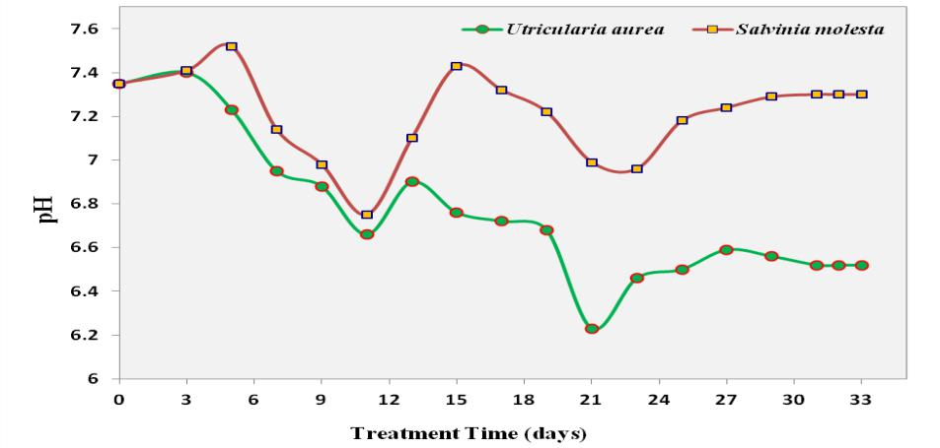

**Fig. 5. Change in pH of (a) *Salvinia molesta* and (b) *Utricularia aurea* after 33 days at 100ppm nitrate concentration**

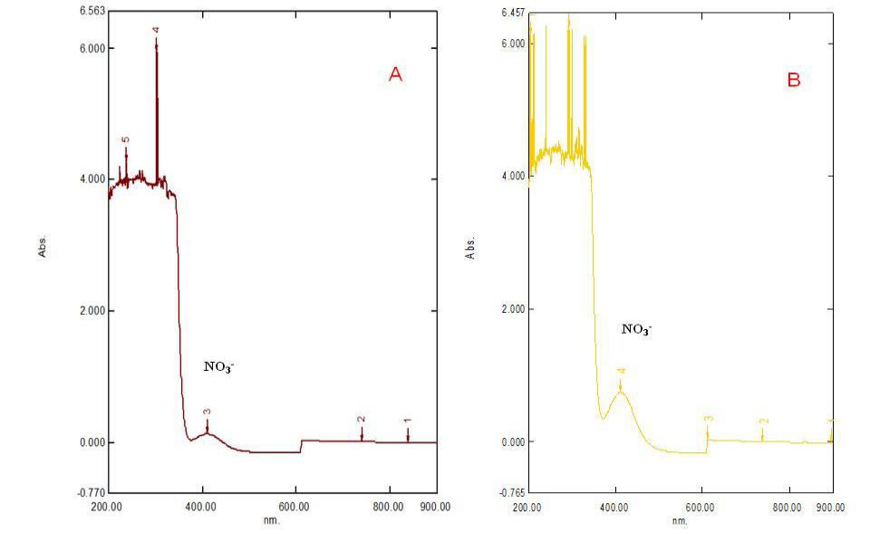

**Fig. 6. Spectral analysis of (a) *Utricularia aurea* and (b) *Salvinia molesta* in terms of OD410nm at 100 ppm nitrate concentration after 33 days**

From the above figure 6, it was observed that the spectral analysis of nitrate indicated the nitrate reduction by aquatic free floating plant (*Utricularia aurea* and *Salvinia* *molesta* ) at 100 ppm nitrate concentration(nitrate rich wastewater). The entire graph was plotted the percentage nitrate removal by means of the residual nitrate concentration present after different treatment time intervals in terms of optical density (OD value at 410nm). The OD values of different treatments by these aquatic plants at different concentration were compared with the OD value of their corresponding standard nitrate

solution. This showed that the peak value of the spectrum after treatment by *Utricularia* *aurea* and *Salvinia molesta* was reducedfrom the initial value (Control). While comparing with standard solution as control, the treated water showed decrease in the concentration of nitrate after treatment period. The nitrate reduction was higher in *Utricularia aurea* treated nitrate rich waterwhile compared to *Salvinia molesta* and it was confirmed that the reduction of nitrate was carried out efficiently by *Utricularia* *aurea* (Usharani and Keerthi, 2018).

155

*Usharani, K. and Keerthi, K.V.*

**CONCLUSION**

The study showed that the plant *Utricularia* and *Salvinia* both are potentialto remove nitrate. While comparing, both plants showed similar activity against nitrate. In brief, the amount of the biomass for *Utricularia* and *Salvinia* are increased considerably in wastewater containing high nitrate concentration. Through this experiment, it could be concluded that the nutrient load in wastewater can be reduced through *Utricularia aurea* and *Salvinia* *molesta,* and thus eutrophication could beavoided. In the other hand, the amount of nitrate decline significantly with respect to increased in time and plant biomass. *Utricularia aurea* was a potentially aquaticplant to stabilize the pH and reduce the nitrate concentration in the wastewater.

However, *Utricularia aurea* was insufficient in trapping more particles after several days particularly in closed batch system of wastewater treatment. *Utricularia* *aurea* was an aquatic plant that has theability to supply oxygen during photosynthesis process and eliminate pollutant material such includes organic material, nitrate and suspended solid. *Utricularia aurea* can decrease theconcentration of nitrate and utilize nitrate to build protein and aquatic animals that eat this plant also use organic nitrogen to build protein. The results revealed that the aquatic plant *Utricularia aurea* (carnivorous) based system of phytotechnology was productively removed the nitrate load from the synthetic wastewater containing nitrate. Therefore *Utricularia aurea* can be measured as asubstitute bioremediation that is low cost and has significant reduction ability at low concentration therefore may be used for the treatment of wastewater containing nitrate in the imminent. There by it was also possible to improve the quality of different wastewaters. The treated wastewater can be used for agriculture, floriculture and aquaculture activities.

**ACKNOWLEDGEMENTS**

The author K. Usharani wishes to thank the Department of Environmental Science, Central University of Kerala and Bharathiar University, South India. She also wishes to extend her sincere gratitude to editor and reviewers.

**CONFLICT OF INTEREST**

The authors declare that there are no conflicts of interests regarding the publication of this manuscript.

**GRANT SUPPORT DETAILS**

The present research did not receive any financial support.

**CONFLICT OF INTERES**

The authors declare that there is not any conflict of interests regarding the publication of this manuscript. In addition, the ethical issues, including plagiarism, informed consent, misconduct, data fabrication and/ or falsification, double publication and/or submission, and redundancy has been completely observed by the authors.

**LIFE SCIENCE REPORTING**

No life science threat was practiced in this research.

**REFERENCES**

Abdel-Raouf, N., Al-Homaidan, A.A. and Ibraheem, I.B.M., (2012). Microalgae and wastewater treatment. Saudi J. Biol. Sci., 19:257– 275. doi:10. 1016/j.sjbs.2012.04.005.

Amalina Amirah Bt Abu Bakar, Khairul Ammar B., Muhd Ali, Nurul Athirah Bt Ahmad Tarmizi,, Ahmad Zia Ul-Saufie B., Mohamad Japeri. and Nor Janna Bt Tammy., (2016). Potential of using bladderwort as a biosorbent to remove zinc in wastewater. International Conference on Advanced Science, Engineering and Technology (ICASET) 2015 AIP Conf. Proc. Vol:774(1), 030023-1– 030023-6; doi: 10.1063/1.4965079 Published by AIP Publishing. 978-0-7354-1432-7/$30.00

APHA. (1998). American Public Health Association, American Water Works Association, Water Environment Federation. Standard Methods for the Examination of Water and Wastewater.

156

*Pollution, 6(1): 149-157, Winter 2020*

Barber ,W.P. and Stuckey, D.C., (2000). Nitrogen removal in a modified anaerobic baffled reactor (ABR): 1, Denitrification. Water Res., 34: 2413–2422.

Chiban, M., Soudani, A., Sinan, F. (2012). Removal of nitrate ions by using low-cost adsorbents: Equilibrium isotherm, kinetics and thermodynamic study. Nova Science Publishers. 31-48.

Dejam, A., Hunter, C.J., Pelletier, M.M., Hsu, L.L., Machado, R.F., Shiva, S., Power, G.G., Kelm, M., Gladwin, M.T., Schechter, A.N. (2005). Erythrocytes are the major intravascular storage sites of nitrite in human blood. Blood, 106: 734 -739.

Health Canada. Canadian Perinatal Health Report. (2003). Ottawa: Minister of Public Works and Government Services Canada.

Joanna Augustynowicz, Krzysztof Łukowicz, Krzysztof Tokarz, Bartosz Jan Płachno. (2015). Potential for chromium (VI) bioremediation by the aquatic carnivorous plant *Utricularia gibba* L. (Lentibulariaceae), Environ. Sci .Pollut. Res., 22:9742–9748. DOI 10.1007/s11356-015-4151-1.

Jorgensen, S.E. (2001). Water quality: The impact of eutrophication. UN Environment Programme.

Keisham Bijyalakshmi Devi, Dharitri Borah, Jayashree Rout. (2018). Algal colonization on an insectivorous plant, *Utricularia aurea* Lour. in a freshwater marsh of southern Assam, India Epiphytic algae on *Utricularia aurea*. Phykos 48 (2): 17-31.

Mikuska, P. and Vecera, Z. (2003). Simultaneous

Determination of Nitrite and Nitrate in Water by Chemiluminescent Flow-injection Analysis. Analytica Chimica Acta., 495(1-2): 225-232.

Mwagona, P.C., Yao, Y., Yuanqi, S. and Yu, H. (2019). Laboratory study on nitrate removal and nitrous oxide emission in intact soil columns collected from nitrogenous loaded riparian wetland, Northeast China. PLoS ONE 14(3): e0214456.

https://doi.org/10.1371/journal.pone.0214456.

Nor Baizura Bt Hamid, Masiri B, Kaamin, Mardiha Bt Mokhtar, Aslila Bt Abd Kadir, Siti Khatijah Bt Abu Bakar, Nurul Huda Bt Ibrahim. (2015). Research on the Effectiveness of an Aquatic Plant (*Utricularia aurea*) for Fish Preservation., J. Civil Engg. Res., 5:1-5.

Ozturk, N. and Bektas, T.E .(2004). Nitrate removal from aqueous solution by adsorption onto various materials. J. Hazard. Mater., 112: 155-162.

Rawat SK, Singh RK, Rana P. Singh (2012) Remediation of nitrite contamination in ground and



surface waters using aquatic macrophytes. J.

Environ. Biol., 33: 51-56.

Saura, R., Silva, Robert Gibson, Lubomír Adamecd, Yoannis Domíngueze, Vitor Miranda. (2018). Molecular phylogeny of bladderworts: A wide approach of *Utricularia* (Lentibulariaceae) species relationships based on six plastidial and nuclearDNA sequences. Mol. Phylogene. Evolu., 118: 244–264.

Seidel, C., Gorman, C. and Werner, K. (2008). Nitrate reduction by sulphur modified iron: pilot study results. Presentation at the American Water Works Association Inorganic Contaminants Workshop.

Taylor, P. (1989). Genus *Utricularia*: A Taxonomic Monograph, first ed. Royal Botanic Gardens, Kew, London. New Taxa

U.S. EPA. (U.S. Environmental Protection Agency). (1987). Nitrate/Nitrite: Health Advisory. Washington, DC: Office of Drinking Water.

Usharani, K., Muthuchamy, M. and Lakshmanaperumalsamy, P. (2011). Biological removal of phosphate from synthetic wastewater using bacterial consortium, Iran. J. Biotechnol., 9(1): 37-49.

Usharani, K., Sruthilaya, K. and Divya, K. (2017). Determination of nitrate utilization efficiency of selective strain of *Bacillus* sp. isolated from Eutrophic Lake, Theerthamkara, Kasaragod, Kerala. J. Poll., 3(1): 55-67.

Usharani, K. and Keerhi, K.V. (2018). Nitrate removal by plant based bioremediation using *Utricularia aurea* from eutrophic Lake of Theerthamkara, India. Conference Proceedings and E-Book of Abstracts of the Joint Conference 7th European Bioremediation Confrence & 11th International Society of Environmental Biotechnology Conference-2018; Chania, Crete, Greece, June 25-28, 2018, ISBN 978-618-81537-6-9.pp 103-104.

Viessman, Jr. W. and Hammer, M.J. (2005). Water supply and pollution control, seventh ed., Pearson Prentice Hall, Upper Saddle River, NJ.

WHO. (1984). Drinking Water Quality Control in Small Community Supplies. In : Guidelines for Drinking Water Quality (vol 3), WHO, Geneva, Switzerland.

WHO. (2007). Nitrate and nitrite in drinking-water. Background document for development of WHO Guidelines for Drinking-water Quality. World

Health Organization, Geneva (WHO/SDE/WSH/07.01/16).

Pollution is licensed under a "Creative Commons Attribution 4.0 International (CC-BY 4.0)"

157